Q1 wap to  initialize string by assigning value in program  and display it

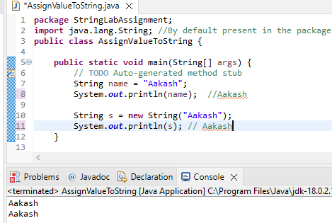

Q 2 wap to ask two string values from user and check if they are equal or not

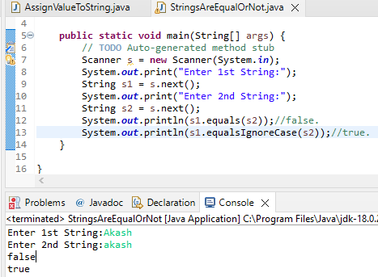

Q 3 wap to compare two strings

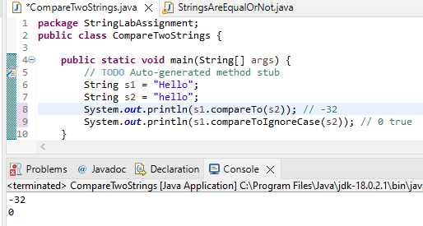

Q 4 wap to print string character by character

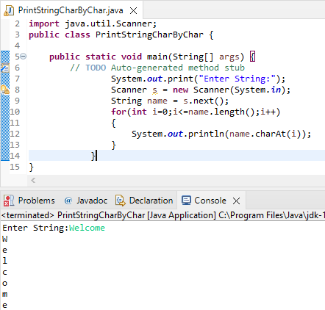

Q 5 wap to check if string is palindrome or not

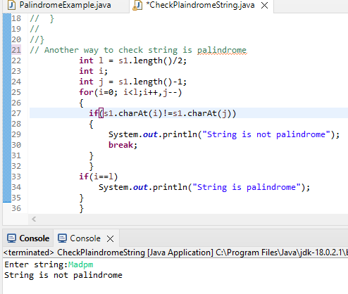

Q 6 wap to count number of vowels and consonants in string

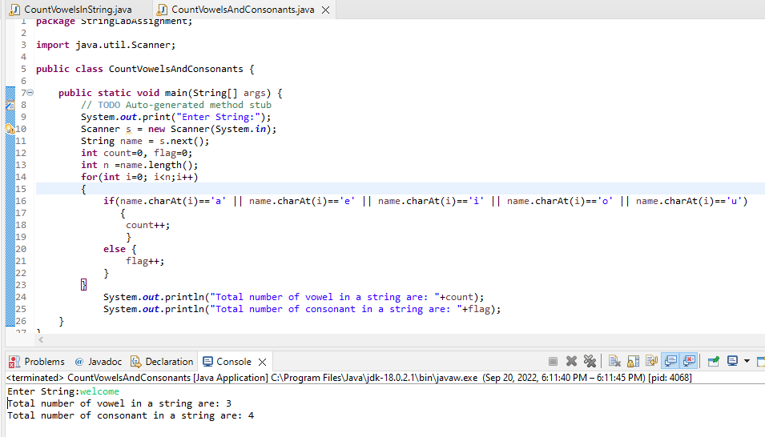

Q 7 wap to count number of words in given string

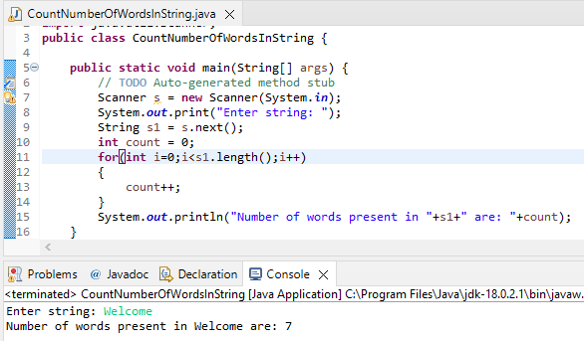

Q 8wap to reverse word in given string

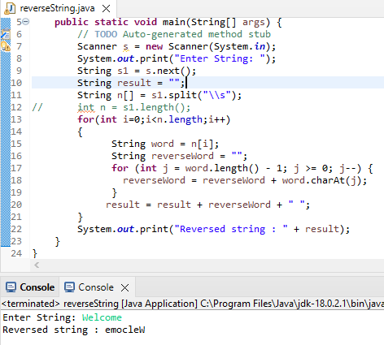

Q 9 wap to ask string from user and search for particular character in given string  .if found print " Found message " else print not found"

